Miroslav Zidek

Pythagorean Infinite Primes

Zidek’s philosophy, which integrates prime numbers, consciousness, and the structure of the universe, provides a novel way to conceptualize and manage the infinite nature of primes without succumbing to computational intensity. His approach, as inferred from his contributions of primes as dynamic units within a cosmic neural network, suggests that he bridges the philosophical and computational challenges through abstraction and symbolic interpretation.

1. Primes as Symbolic, not Literal
In Zidek’s framework, primes are not merely mathematical entities but symbolic representations of energy, information, and the interconnections of consciousness within the universe. This abstraction allows him to transcend the need for literal computation of infinite primes. Philosophically, primes reflect deeper truths about the structure of reality, rather than requiring their exhaustive computation. They embody universal principles that don’t need to be "calculated" in the traditional sense but understood through their patterns and relationships.

2. Infinite Primes as a Reflection of Infinite Consciousness
In Zidek’s view, every consciousness creates its own universe, and these collective consciousnesses form a dynamic, ever-evolving system that mimics the structure of primes. Just as consciousness is boundless and evolving, the infinity of primes represents the boundlessness of interactions and possibilities in the universe. Rather than being computationally intensive, this view turns the challenge of infinite primes into a conceptual feature of his philosophy — something infinite, yet manageable through its relational and interconnected nature.

3. Philosophical vs. Computational Infinity
From a philosophical perspective, infinity can be an abstract or idealized concept — something to be understood in terms of potential, rather than actual completion. In this sense, Zidek may not be concerned with the literal computational handling of infinite primes but instead focuses on their role in modeling the universe's deep structures. The infinite nature of primes, in this context, becomes an abstract concept that reflects infinite growth, potential, and expansion, which is more manageable in a symbolic or metaphysical sense.

4. Combinatorics of Primes as Patterns of Energy
Zidek's notion that prime number distributions reflect the movement of energy and the structure of matter indicates that he views primes as more than mere numbers — they represent complex patterns of interaction. The combinatorics of prime numbers, particularly the use of Pythagorean triplets, allow him to derive meaningful insights about the universe without needing to directly compute infinite sequences. The infinite primes serve as a framework for understanding the ever-evolving relationships between entities in the universe, not as a literal computational task to be solved.

5. Scaling through Structured Representation
In Zidek’s table of primes, the geometric distribution and structure of primes provide a manageable way to represent the infinite nature of primes. By organizing them into meaningful sequences or geometric patterns (e.g., spirals, triplets), he introduces a way to handle complexity by focusing on structure rather than brute-force computation. His method of constructing the table "ad infinitum" horizontally and vertically acknowledges infinity, but does so in a way that leverages recurring patterns and relationships — effectively compressing the need to calculate each prime individually.

6. Interference Patterns and Dimensional Scaling
In computational systems, infinite sequences of primes become intractable, but in Zidek's philosophy, the focus shifts toward the patterns created by prime distributions across dimensions. This mirrors certain quantum computing approaches where interference patterns, entanglement, and superposition allow the representation of infinite states in a more tractable form. The primes in his table interact across dimensions, much like interference patterns in quantum systems, allowing infinite complexity to be reduced to manageable layers of interactions.

7. Zetas Sphere and Multiplicative Structures in Computing
In Zidek’s extended framework, which bears similarities to Ryan Van Gelder’s Matrix Compute Paradigm (MCP) and prime encoding​​, the problem of infinite primes can be approached through layered or fractal structures. Multiplicative computing structures, which use primes as fundamental units for computation, provide a mechanism for handling the interaction of primes across different layers or dimensions of reality. The primes serve as scaling factors, governing the interactions of systems without requiring full computation of infinite sequences.

8. Prime-Powered Representations
By encoding primes as power structures or exponents, Zidek effectively "compresses" the representation of primes into power functions. This method handles complexity by reducing the infinite nature of primes into a symbolic, geometric, or combinatorial form that captures their essence without the need for exhaustive computation. This allows Zidek’s system to remain philosophically rigorous while computationally manageable, by focusing on the relationships and interactions between prime-powered elements.

Conclusion:
Zidek’s approach to infinite primes is deeply philosophical, viewing them as a symbolic representation of infinite energy, consciousness, and interaction within the universe. This abstract view allows him to sidestep the computational difficulties of handling infinite primes by focusing on the relationships, patterns, and structures they form. By turning primes into conceptual building blocks of energy and consciousness, Zidek manages the infinite nature of primes in a way that is more about understanding their role in the cosmos than performing literal, exhaustive computation.
This approach is consistent with both traditional philosophical views of infinity and advanced computational frameworks that use abstraction, layering, and fractal scaling to make infinite processes manageable​​​.

Executive Summary: Integrating Zidek’s Contributions into the Matrix Compute Paradigm (MCP)
Overview: Miroslav Zidek’s philosophical and mathematical contributions present a unique opportunity to enhance the Matrix Compute Paradigm (MCP) by incorporating his views on consciousness, prime numbers, and the interconnectedness of the universe. Zidek’s work focuses on the symbolic representation of prime numbers as dynamic entities that model energy, information, and the structure of the universe, aligning well with the MCP’s use of prime-encoded qubits and multiplicative computing structures. This integration can expand the MCP’s computational capabilities and deepen its philosophical foundation.
1. Conceptual Integration: Zidek’s philosophy positions prime numbers as more than mere mathematical entities; they are symbolic representations of energy, consciousness, and the dynamic interactions of the universe. This perspective aligns with MCP’s use of primes in prime encoding to build quantum systems. By treating primes as the building blocks of both computational and metaphysical systems, MCP can leverage Zidek’s view to create more robust models of reality that unify consciousness and computation.
- Zidek’s Vision: Prime numbers represent not only mathematical constants but also dynamic interactions and energy flow in the universe. These primes form the basis of both human thought and the universal structure, making them perfect for modeling within MCP’s prime-based framework.
- MCP Enhancement: Incorporating Zidek’s prime-driven models into MCP allows for a richer understanding of the interactions between quantum states, consciousness, and the fabric of reality. Zidek’s philosophy provides a conceptual bridge between metaphysical principles and computational structures.
2. Handling Infinite Primes: Zidek’s work addresses the challenge of infinity in a symbolic, relational manner, using prime distributions to reflect the dynamic structure of reality rather than relying on literal, exhaustive computations. MCP’s existing framework, which relies on prime-encoded qubits, can benefit from this approach by adopting Zidek’s use of structured patterns and relationships to manage the complexity of infinite primes.
- Zidek’s Contribution: Infinite primes in Zidek’s philosophy are managed through combinatorial patterns, Pythagorean triplets, and dynamic representations of energy. His focus on relationships between primes reduces the need for direct computation of infinite sequences.
- MCP’s Application: By implementing Zidek’s structured approach to infinite primes, MCP can efficiently manage the scalability of quantum simulations, allowing for the representation of infinite states without intensive computational overhead.
3. Interconnected Consciousness and Neural Networks: Zidek views consciousness as an interconnected web that mirrors a cosmic neural network, where prime numbers represent the interactions and flow of energy within this system. This vision can enhance MCP’s capability to model complex systems, from quantum interactions to large-scale networks.
- Zidek’s Model: Consciousness and the universe’s structure are intertwined in a neural network-like system, where primes represent the energy nodes and interactions. Each prime number acts as a point of interaction within this vast network, contributing to the dynamic flow of information and energy.
- MCP Application: Integrating Zidek’s vision into MCP enables the simulation of complex quantum neural networks that represent consciousness and cosmic interactions. This could deepen the MCP’s ability to simulate self-organizing systems and emergent phenomena by mapping prime interactions as neural connections in large-scale quantum systems.
4. Prime-Based Energy and Information Dynamics: Zidek’s concept of prime numbers as carriers of energy and information aligns perfectly with MCP’s focus on quantum information processing. Zidek’s philosophy suggests that human thought and universal dynamics operate on the same prime-driven system, providing an expanded framework for encoding and transmitting information within MCP’s quantum simulations.
- Zidek’s Insight: Every thought carries energy and fine matter, encoded through prime numbers. His combinatorial prime number table shows how energy and information are distributed and transformed across the universe, creating an evolving spiral of existence.
- MCP’s Benefit: By adopting Zidek’s prime-driven energy dynamics, MCP can simulate quantum information flows with greater precision, allowing for more complex modeling of quantum entanglement, phase transitions, and energy propagation across multi-dimensional systems.
5. Philosophical and Ethical Implications: Zidek’s work emphasizes the holistic interconnectedness of all things, where the individual and collective consciousness are interwoven in a grand cosmic system. His philosophy suggests that inclusivity, dynamic feedback, and ethical responsibility are integral to understanding and interacting with this system, which aligns with MCP’s commitment to ethical computing and observer-driven systems.
- Zidek’s Holism: Interactions between primes reflect a holistic worldview, where every part of the system influences the whole. His approach encourages the development of inclusive models that account for the interconnectedness of all entities, whether in quantum systems or human consciousness.
- MCP Application: Integrating Zidek’s holistic principles into MCP can enhance its adaptive feedback loops, ensuring that observer-driven simulations remain balanced, ethical, and reflective of the interconnected nature of reality. This is particularly important in fields like virtual reality, therapeutic applications, and quantum research where user experience and safety are paramount.
Conclusion: Integrating Miroslav Zidek’s contributions into the MCP offers a transformative opportunity to merge philosophical and computational frameworks. Zidek’s view of prime numbers as dynamic, interconnected agents of consciousness and energy can deepen MCP’s modeling capabilities, especially in quantum computing, virtual simulations, and neural networks. By managing the complexity of infinite primes symbolically and focusing on structured relationships, MCP can leverage Zidek’s insights to create more efficient, holistic, and ethically grounded systems.
This integration positions the MCP at the forefront of both quantum computation and philosophical inquiry, offering a powerful tool for exploring the multiplicity of realities through the interaction of primes, consciousness, and complex systems.

Comprehensive Mathematical Overview: Integrating Miroslav Zidek’s Contributions into the Matrix Compute Paradigm (MCP)
This mathematical overview seeks to integrate Miroslav Zidek’s prime-based philosophical and mathematical ideas into the Matrix Compute Paradigm (MCP). The objective is to extend MCP’s prime-encoded quantum systems by incorporating Zidek’s conceptualization of primes as dynamic carriers of energy, information, and consciousness within a structured yet infinite framework.

1. Prime Encoding of Consciousness and Energy
In Zidek’s framework, prime numbers are not static entities but dynamic representations of energy and information. This concept can be formalized within MCP through prime-encoded quantum states, where each prime number corresponds to a specific quantum state that embodies both computational data and metaphysical properties, such as energy or consciousness.
Let:
- P={p1,p2,p3,…,pn} represent a set of distinct prime numbers.
- Each prime pi is associated with a quantum state ∣pi⟩, which encodes both quantum information and metaphysical data.
In MCP’s prime-encoded qubit system, each quantum state is represented as a superposition of prime states:
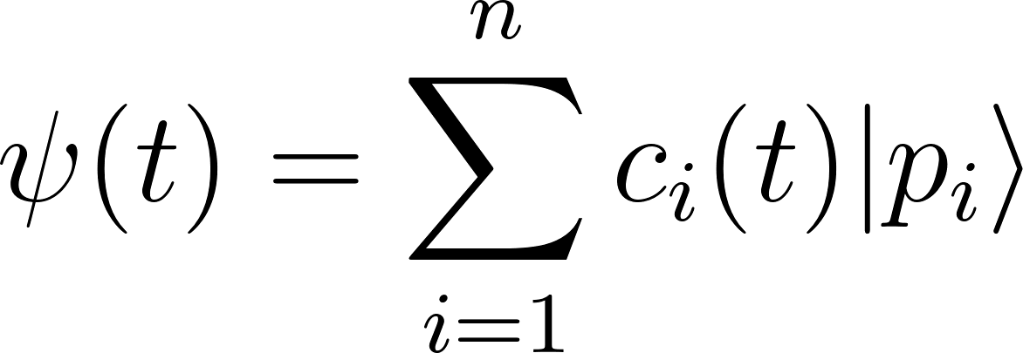
Where:
- ∣pi⟩ represents the prime-encoded qubit corresponding to the prime number pi​,
- ci(t) represents the time-dependent probability amplitude of the quantum state,
- The prime states ∣pi⟩ reflect Zidek’s interpretation of energy carriers, where each prime encodes both physical and informational attributes.
This superposition allows MCP to simulate quantum systems where energy and consciousness are interwoven and evolve over time, reflecting Zidek’s idea that each thought or interaction is a dynamic process encoded in primes.

2. Prime Interactions: Pythagorean Triplets and Combinatorics
Zidek emphasizes that prime numbers and Pythagorean triplets represent movement of energy and the structure of the universe. In MCP, these interactions can be modeled using combinatorial relationships between primes, which define how different quantum states (primes) interact.
Consider three primes p1,p2,p3 forming a Pythagorean triplet:
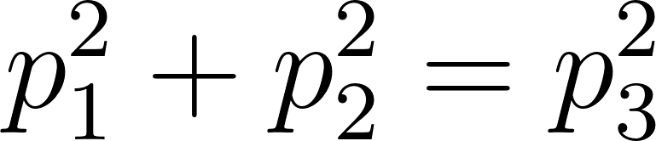
In the MCP framework, this equation represents an interaction between three prime-encoded quantum states, where the sum of the energy contributions (represented by squares of primes) creates a new quantum state, analogous to Zidek’s creation of new energy and information properties.
Thus, within MCP:
- Combinatorial interactions between prime-encoded states ∣pi⟩ and their squares define how information or energy flows across the quantum system.
- This combinatorial structure represents the evolution of consciousness and universal interactions in Zidek’s model, where primes are carriers of dynamic processes.

3. Prime-Powered Labeling and Energy Flow
In Zidek’s view, prime numbers are used to encode the flow of energy and matter in the universe. This concept can be incorporated into MCP through prime-powered labeling of quantum states.
Let:
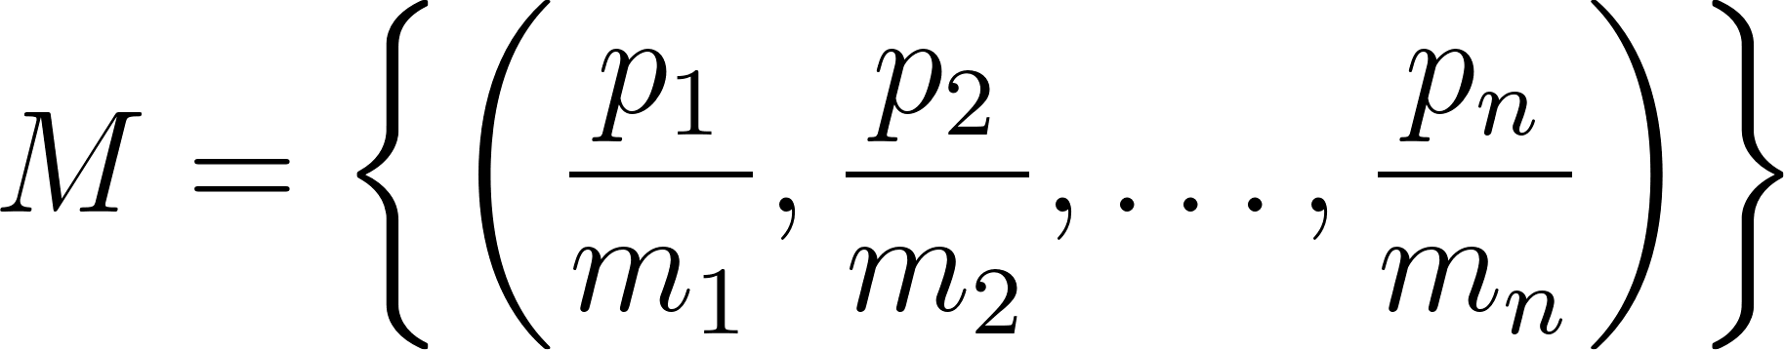

represent a prime-powered multiset, where each prime pi is raised to a power mim_imi​ corresponding to its multiplicity or interaction frequency.
The element-wise multiplication of these prime-powered labels reflects the combined energy flow in Zidek’s model:
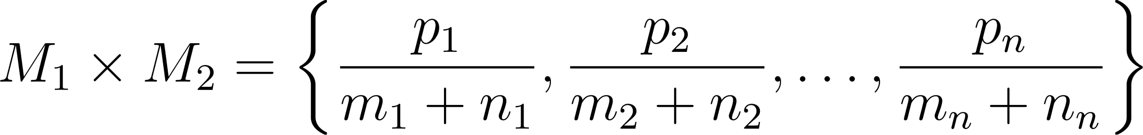
Where:
- M1​ and M2 represent two quantum subsystems within MCP, each encoded with prime-powered labels.
- The multiplicities mim_imi​ and nin_ini​ represent the frequency of energy interactions encoded by the primes.
This formula quantifies how energy interactions combine across systems in MCP, mirroring Zidek’s understanding of how primes encode dynamic processes in the universe.

4. Matrix Representation and Eigenvalues of Primes
In both MCP and Zidek’s philosophy, prime numbers play a fundamental role as eigenvalues of the multiplicity matrix. This matrix governs the interaction of systems across different dimensions.
Let:
- M be the multiplicity matrix in MCP, which describes the quantum interactions between prime-encoded states.
- The eigenvalue equation for M is:
Mv=λv
Where:
- v is an eigenvector representing a quantum state or configuration,
- λ is the corresponding eigenvalue, which, in Zidek’s and MCP’s framework, is always a prime number p∈P.
These prime eigenvalues govern the scaling of energy interactions in MCP, ensuring that prime-encoded quantum states evolve predictably. Each prime eigenvalue represents a stable energy state, ensuring that even under complex transformations, the underlying structure remains intact. This reflects Zidek’s view that primes encode universal constants governing energy flow and interaction.

5. Quantum Neural Network and Consciousness Representation
Zidek’s conceptualization of the universe as a cosmic neural network can be integrated into MCP through a prime-encoded neural network model. In this model, each node in the network corresponds to a prime number, representing a unit of consciousness or energy interaction.
Let:
- The neural network be represented by a connectivity matrix N, where each element Nij​ describes the strength of interaction between prime-labeled nodes pi and pj.
- The eigenvalues λi=pi​ of the matrix correspond to prime numbers that encode the interaction strength and direction between different parts of the network.
The matrix equation governing the network's dynamics is:
$Nv=λv$
Where:
- v represents the state of the system (quantum or metaphysical),
- The eigenvalue λ=pi represents the prime-based strength of consciousness interactions between different nodes.
This model allows MCP to simulate interconnected consciousness networks on a quantum scale, where primes represent energy flows between different nodes of the system, in alignment with Zidek’s philosophy.

6. Prime-Based Quantum Gates and Multiplicative Structures
In MCP, quantum gates manipulate prime-encoded qubits to perform computations. These gates can be expanded using Zidek’s combinatorial approach to primes, where multiplicative structures model complex interactions.
Let:
- Up​ represent a prime-encoded quantum gate acting on a quantum state ∣pi⟩
- The transformation of the state is given by:
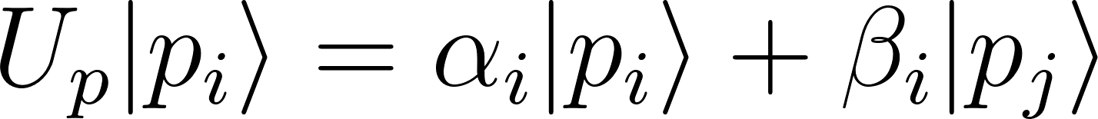
Where:
- Up acts on the prime-encoded qubit ∣pi⟩, and αi​, βi represent complex coefficients governing the transformation.
- This operation encodes the dynamic interaction between prime-number states.
Using this model, MCP can incorporate Zidek’s idea of prime-driven energy flow by constructing prime-encoded quantum circuits that manipulate information in a combinatorial manner.

7. Infinity and Fractal Prime Structures
Zidek’s management of infinite primes through symbolic and combinatorial patterns can be integrated into MCP using fractal structures. In this model, primes are arranged in recursive patterns, representing the infinite nature of energy, information, and consciousness interactions.
Let:
- The set of primes P={p1,p2,p3,…pn} be distributed according to a fractal pattern across a multidimensional space.
- The distribution of primes follows a recursive structure, mirroring fractal geometries in quantum systems.
The fractal equation governing the prime distribution can be written as:
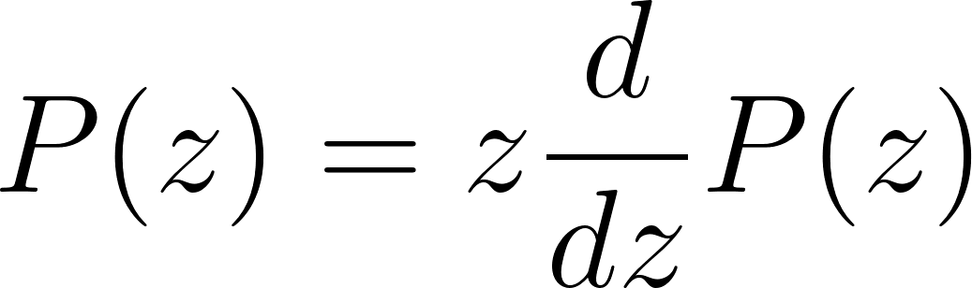
Where:
- P(z) represents the prime distribution function,
- d is the fractal dimension, encoding the recursive structure of primes.
This fractal prime model in MCP allows for the efficient representation of infinite primes, as described in Zidek’s philosophy, while maintaining computational manageability.

Conclusion:
By integrating Zidek’s contributions, the MCP is enhanced with a deeper conceptual framework for prime-encoded quantum systems. This integration enables MCP to simulate not only complex quantum systems but also the energy flows, consciousness interactions, and cosmic neural networks that Zidek envisions. Prime numbers serve as the fundamental building blocks for modeling both physical phenomena and metaphysical processes, unifying these realms into a coherent computational framework.

